**Instructions for RDI**

Creating the reference library:

1. Log into analysis

**ssh -XY [username e.g. abc123]@analysis.astro.ex.ac.uk**

1. Navigate to your champion stars folder in the DangerZoner

**cd ../../../data/shinkley/Keck_Data/completed_stars/DangerZone/HR8799**

1. List all the files in this folder

**ls**

There should be folders with the names of their epochs e.g. 2012aug28. Make a note of your chosen epoch

1. To find a list of all the stars with this same epoch, navigate back to the DangerZone folder

**cd ../**

**find -name "2012aug28"**

where 2012aug28 is your epoch – this should produce a list of stars that needs to be in a text folder.

1. The text file of the list of targets needs to be in this form, including the underscore in the star names:

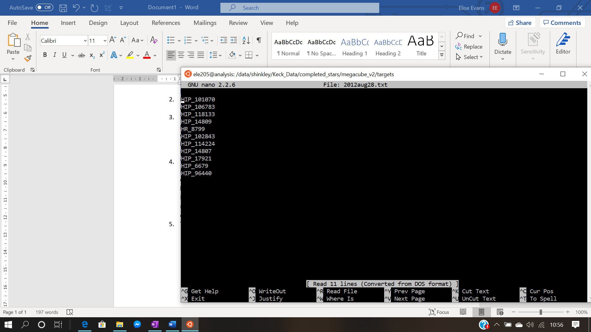

To create this file navigate to the targets folder in megacube_v2, which is in completed_stars. If you’re in the folder completed_stars:

**cd megacube_v2/targets**

**umask 0000** (This is so the files you create will have rw permissions for all so that others can use the same files for the epoch)

**nano <epoch>.txt** where epoch is in the form 2012aug28

and then write the list of stars, and save and exit using Ctrl X.

You could also create this file on your laptop and copy it to the targets folder using:

**scp <epoch>.txt abc123@analysis.astro.ex.ac.uk:/data/shinkley/Keck_Data/**

**completed_stars/megacube_v2/targets**

1. Navigate to the megacube_v2 folder

**cd ..** (if you’re in the targets folder)

1. Run the cubestitch code using:

**python cubestitch4.py -create <epoch>** where epoch is in the form 2012aug28

1. Outputs:

* <epoch>_megacube.fits (in output folder) --- The reference cube
* <epoch>__target_frames_data_megacube.csv (in stitch_data folder) --- A dictionary of each star in the reference cube and their corresponding image numbers
* <epoch>__angles_megacube.csv (in stitch_data folder) --- A dictionary of each star and their parallactic angles

1. Open ds9 and the <epoch>_megacube.fits file (ds9 is found in analysis in **usr/local/ds9** then **./ds9**) and check that all the stars align with 512,512 at the centre.

If they don’t:

There is a automatic align function but that works if all the stars are in roughly the same place. There is a manual_align function that can be used if you think every image of one star is massively off. You can open the <epoch>__target_frames_data.csv file using nano and find the name of the star corresponding to the frames that are not centred. Then if you run:

**python cubestitch4.py -manual_align <epoch>**

It will loop through asking if you want to align each star and then ask for the coordinates of the centre of the star.

To align the images using a 2D gaussian:

**python cubestitch4.py -align <epoch>**

This creates a new fits output <epoch>_aligned.fits

The RDI only looks for a _megacube file so if they did have to be aligned then rename the file

**cd output**

**cp <epoch>_aligned.fits <epoch>_megacube.fits**

OPTIONAL

The correlation code automatically removes the worst correlated images so removing the bad frames manually is unnecessary but if you need to for some reason:

1. If there are bad frames, a file needs to be created in megacube_v2/badframes called <epoch>.txt which can be done in the same way the target file was created in step 5.

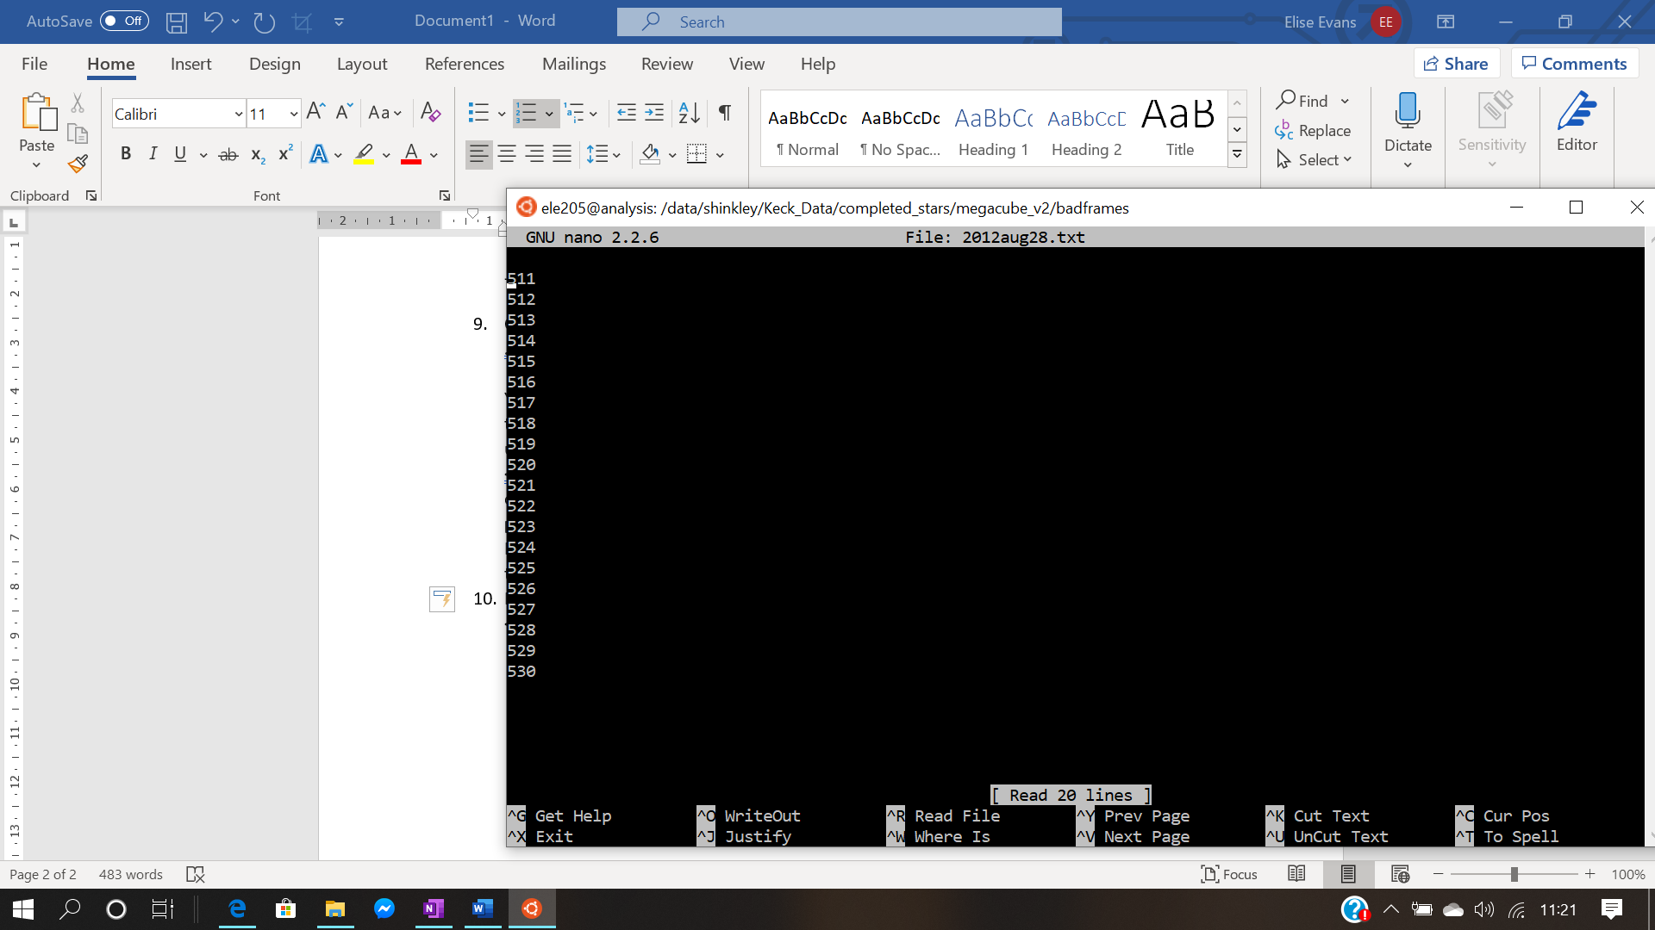

1. The bad frames can be removed using:

**python cubestitch4.py -remove <epoch>**

This produces a new fits file called <epoch>_trimmed.fits as well as removing the frames from the two dictionaries in stitch_data

The RDI code takes the _megacube files as the input so if you want to use the trimmed files you’ll have to edit the code in RDIv4.py

Running the RDI code:

1. Navigate to your stars folder in DangerZone and create a new folder called RDI and a folder called correlation in RDI.

For example, from megacube_v2:

**cd ../DangerZone/<Star>**

**mkdir RDI**

**cd RDI**

**mkdir correlation**

1. In this folder, you’ll need the RDI script, the correlation script and the script combining them as well as the psf.fits file

**cp ../../HIP66707/RDI_correlation/*.py .**

If the psf is in the epoch’s folder:

**cp ../<epoch>/psf.fits .**

1. To run RDI:

**python -W ignore RDI_correlation.py <epoch> <star> <Maximum PCs>**

e.g python -W ignore RDI_correlation.py 2012aug28 HR_8799 10

* For each RDI run it iterates through the max PCs number so too high can take a long time (It also can’t be more than the number of target images so RDI_correlation.py changes it to the max if it’s too big)
* You need to enter the minimum, maximum and step size for the percentage. This is the percentage of the reference cube that will contain target images, with the rest of the images being the best correlated images.
* It’ll ask you for a coordinate of a bright spot, If you’re doing this on a star you’ve already run the project script for then you might have some coordinates written down. If you don’t you’ll need to open the megacube (found in megacube_v2/output) in ds9 and note some coordinates

1. Outputs:

* It’ll first create the correlation reference cube, saved in the correlation folder along with the target frames and angles files. If not all the target images were used then the actual percentage and the input percentage might be very different so it tries again to produce another cube with (hopefully) a closer percentage to the input.
* It loops through RDI for each of the correlation cubes, printing the optimal number of PCs in the console
* It’ll print out the value for the contrast at 1 arcsecond and say which percentage gave the best results and saves the files for just this RDI run (apart from the contrast curve data)
* <star>_RDI_<epoch>_PCAS.fits --- A cube containing the processed images for each PC (the first image is PC=1, the second is PC = 2 etc, so the image with the optimal number of PCs can be chosen)
* RDI_contrast_curve_<epoch>.png --- A picture of the contrast curve for the optimal number of PCs for the best percentage
* RDI_contrast_curve_<epoch>_<percentage>.txt --- A text file of all the data from the contrast curve – this will be saved for each percentage entered.
* RDI_snr_<epoch>.txt --- A text file of the signal to noise ratio for each PC, this can be mostly ignored it just demonstrates the optimal number of PCs has the best S/N ratio

1. To run ADI:

**python -W ignore RDIv4.py <epoch> <star> <Maximum PCs> ADI**

e.g python -W ignore RDIv3.py 2012aug28 HR_8799 1 ADI

* This produces the same outputs as RDI (but with ADI instead of RDI in the title)

Possible errors:

1. Originally I got an error that the vip module was not installed. I fixed this by installing miniconda on my home directory

**wget https://repo.continuum.io/miniconda/**[**Miniconda3-py37_4.8.3-Linux-x86_64.sh**](https://repo.anaconda.com/miniconda/Miniconda3-py37_4.8.3-Linux-x86_64.sh)

**bash** [**Miniconda3-py37_4.8.3-Linux-x86_64.sh**](https://repo.anaconda.com/miniconda/Miniconda3-py37_4.8.3-Linux-x86_64.sh)

**pip install vip-hci**

* VIP will only work on python version 3.7 (not 3.8 currently)

1. I found that some of the stars didn’t have a centred cube in their dangerzone folder so the cubestitch code came up with an error saying the file didn’t exist. You can check you’ve typed the name of the star correctly and then just remove this star from the list of targets. This also applies if the centred cube is not in the normal location as the code won’t be able to find it.